Interview with four refugees, Leutkirch, 11st November 2015
11. novembra 2015 je imela skupina Škofijcev, ki je v okviru projekta Facing Discrimination (Europeans for Peace, EVZ) obiskala Leutkirch, priložnost spregovoriti tudi z nekaterimi begunci in migranti, ki so (v mesecih, ko so čakali na odločitev nemške vlade glede azila) obiskovali pouk nemščine v okviru Geschwiter Scholl Schule. Pogovarjali smo se z Afričanoma Samuelom in Thomasom, ki sta dobro govorila angleško, ter z Saidom in Zano, Kurdoma iz Sirije. V začetku so (smo) bili vsi kar precej zadržani, potem pa je beseda stekla do te mere, da smo kar težko zaključili. Še posebej se nas je dotaknila Thomasova pripoved… Begunci oz. migranti (kako sploh pravično določiti mejo med obema pojmoma?) se žal niso želeli fotografirati z nami.
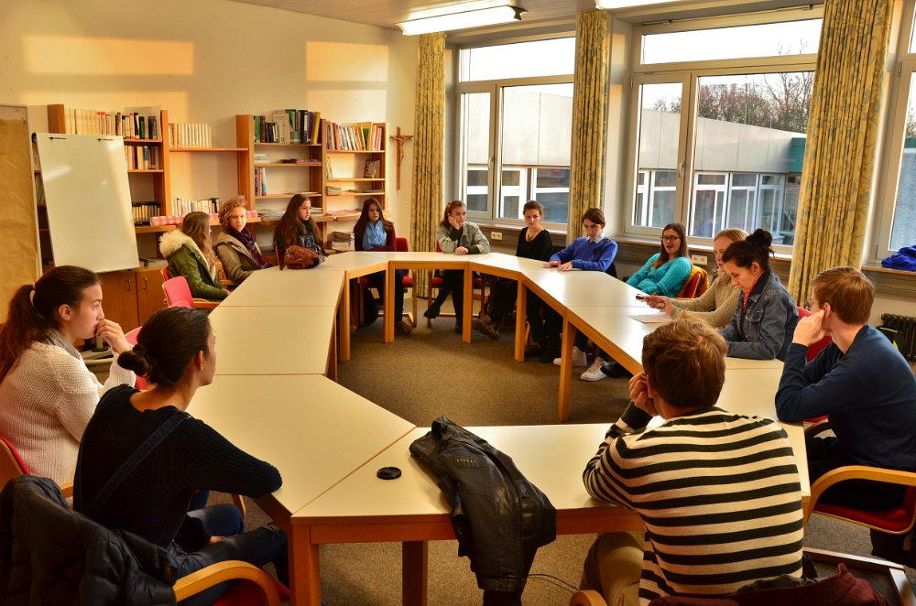
Photo: Waiting for Samuel, Thomas, Zana and Said at Geschwister Scholl Schule in Leutkirch

So, our first question for you is: where are you coming from?
Samuel: I´m coming from West Africa, Gambia.
Thomas: I´m from central Africa, Cameroon. We were living in a small forest for at least I think nine months, I think so. Then I went to Morocco. In Morocco I stayed for around one year and two months. Then I went to Spain, and there I took a bus to Germany.
And what about you Samuel?
Samuel: Yes, ahm for me my story is different... I came through with the flight. From Gambia to Germany. But other people from my country they go from Gambia to Senegal, Senegal to Mali, Mali to Niger, Niger to Libya. From Libya to Italy, Lampedusa. And from there most of them take a bus or a train to Germany.
And how old are you?
Thomas: I´m nineteen years.
Samuel: And I´m eighteen years old.
So actually when you left, how old were you then? When you left your country, because the journey to Germany took quiet a lot of time.
Thomas: When I left Cameroon, I was sixteen and two months, yes I think so. Then I decided to live on my own, but sometimes you can´t live, because of conditions… So I decided to take my way and to live on my way.
Samuel: For me… I´m just like for six months in Germany, I left Gambia with eighteen years and I´m still eighteen, I will be nineteen in December.
And what about German language now? Do you speak enough now to communicate? Basic things?
Thomas: Yes I think, I’ m learning for nine months, so someone in nine months can try to communicate with someone else, when you need the language and you learn it, you can make it.
It´s faster…
Thomas: Yes it is.
Samuel: Especially after school, when you go back on, you can practice. Then you start to socialize with people. It´s very easy to speak.
I have a question for Tomas, and maybe also for Samuel: when you decided to leave, how did your parents take this decision?
Thomas: So how did my family take it…. I don´t really want to talk about my family, what I want to say is, that is a really big family. I wouldn´t actually say like this but okay, it´s my mother. That´s all. According to me she had no decision in that, but she was against my decision … but I could not bear that way of living so that´s why I decided to take my way. So there are lot of conditions that brought me here, but they are almost all private conditions, I can´t say it in front of people.
So there were mostly private conditions that made you leave?
Thomas: Yes, my conditions were mostly private.
Oh, okay. And what about you Samuel? Are your conditions more private or more political?
Samuel: No for me there´s only one circumstance that made me leave, and it´s because of political system of Gambia. Our government is really bad, and it´s not good for living. So I went to seek for a better life. As I told you I came by plane, but most of my brothers and sisters from Gambia took a road here.
What are your expectations from Germany? What do you think you could do?
Samuel: For now one of the most important things it´s to learn language, to speak. To find a good job in the future and to settle down.
Thomas: And for me is that I also like Germany, I really want to forget my past. It´s not good to pass through what I passed through in my country, in my land, the people of my family. So now I´m trying not to have a lot of contacts with people from my family, because I don´t like my family. My only family it´s actually my brother. I´m in Germany because I want to start a new life. And to try to forget everything. You know for us Africans, it´s not easy to sleep, I can´t sleep for more than two hours, then I wake up, because I have some dreams that come to my head about my country… about the way here, some things I saw…. So I like coming to school, because it´s a place where I can free my mind, and forget about everything that happened to me.
What do you do to “free your mind”? To be happier, more relaxed?
Thomas: I free my mind when I´m doing my sport. It´s not so easy for me to talk to people or to have friends. I don´t really have things that make me happy or relaxed. I ´m sorry.
What kind of sport do you like?
Samuel: In Africa I think we all like football.
Tomas: I also like football but before I was also training boxing and karate. But I especially like football.
You both speak very good English. Where did you learn to speak it?
Samuel, Tomas: In school.
So you were actually learning English for 8 years in school like in Europe?
Samuel: No there is a different system in each place in Africa. For us we have like… when you start going to school you first go to primary school, it lasts till you are 7 years old. Then is junior school from 8 to 9. Then is senior school from 9 to 12. And then when you finish senior school you go on University. When I finished my senior school I went on to the University but I was really stressed because of the system and it was really expensive.
Do you have to pay to go to secondary school?
Samuel: Yes, you actually have to pay from the very beginning and it becomes even more expensive when you go to the University.
Thomas: Where I used to live it is a little bit different. We have primary school for 7 years and then we can go on the college also for 7 years, but it’s really expensive and that’s why most of the people in Africa go to school just for two years . But there are some family’s that don’t have enough money so children must stay at home and they can`t educate themselves but sometimes children want to go to school so bad that they start to work so they get some money to educate. So I proposed our social worker and my parents to go to school. When my parents told me that I can go to school I was so happy because I enjoy going to school. And I know how this is important. That’s why I tried to encourage my brothers and sisters to go to school. So what I want to tell is that you have to believe in what you do and never ever give up. Just do what you can do and you will see what your future will be like.
This is very different from thinking from our children; because they can get a really good education but they don’t appreciate it… What would you like to do later in life? Do you have any dreams?
Thomas: I think that any job would be good for me. When I was young, 14 I think, I wanted to do constructions of houses, but now I don’t really want to do this work because I think I want to help people…
Samuel: I just want to finish school. When I was young I wanted to be an automechanic, but now I don’t know anymore. I just want to take my time and concentrate on school.
Have you made any friends? Do you have often contact with others? What is your experience with them?
Samuel: You know for most of the people I’m something new for them. Especially because I’m black, so when I go out its very difficult for us.
So you use sport, football to enter their world?
Samuel: Yes, I think that everyone has a vision; I’m a shy guy so I just like to be more by myself. But I think here is a totally different world. It’s hard for them to see a black guy and it’s very difficult for us too. There will be changes in the future I hope.
Thomas: I know for me at the beginning it wasn’t so easy. My only way to make friends is to enter group sports – football, but it’s still really difficult.
What about the weather here? Was it hard for you to adjust to the cold? It´s probably a lot colder here…
Thomas: There was really a problem when I arrived, it was in February I think. I think the snow was… for me it was 5 meters high but it was only 2 meters. I have never seen snow before in my life, the only time I saw snow was on the television. So the first day I arrived, I saw snow and I was being like a child. Sometimes I asked myself if I was dreaming, but it´s actually very cold and we´re adapting to the situation. I think we´ll make it.
Samuel: For me, this my first winter season… it´s cold.
Everybody: (hahahahaha)
Do you plan to stay in Germany for the rest of your life or maybe move somewhere else?
Thomas: Eeemm.. I came to Germany…………So if I came to Germany, I´ll stay in Germany. I don’t really know if the conditions would let me stay in Germany or not. But actually I really want to stay in Germany.
Samuel: That`s the reason why we left our country. But the decision, it doesn’t have to do with us, it has to do with the German government. They have to make the decision… We just wait and hope everything will be OK.
Why Germany, why not England for example?
Or France … it`s sometimes better to communicate in French language than in English or German…
Thomas: Yeah, French language is our mother language. I love the language, but actually the French people… I read about the history of Cameroon, what happened in the past… The Germans, they colonized Africa and Cameroon I think. Then after the war, Cameroon was devided in two parts. And since this time (after Germans left) everything was not so good. All the companies now are for the French people in Cameroon. Mostly we do the job. I was working with the construction of houses, I worked for maybe 1 year. A day from the morning 7 o´clock to maybe 17 o´clock I think so, or 18 o´clock. Then after I got 3€ for all this work. Actually for me, I don´t like this land. Sorry.
Ja, because for you they were practically… countries which exploited or exploit your country?
Thomas: Yeah, at the beginning they were not so friendly to us because they were, sometimes they say, what you did to us... When I read, what Germany introduced in the Cameroon, there are some houses or schools that are different from constitutions in Cameroon. But the French people they are showing nothing, but they keep on exploiting our countries, that is all. So why should I go there (to France)? I have no reason to go there. They have all my friends. That’s all I think.
Samuel: So why Germany for me…. It’s a very long story. I chose Germany, because since I was a kid, I heard a lot about Germany. I watched the TV and I know a lot about Germany. But when I first came here, the language was very difficult. What I said to myself, it was my dream to come to Germany, so I have to achieve that dream, so I chose to stay here and everything will go its way… And for us to go to England even if we were colonised by British, it was difficult, because the president is a dictator so he has a problem with the British government, so it was very difficult. We are no longer even in the Commonwelth, Gambia is no longer in the Commonwealth. We don´t even have the embassy in Gambia, the British embassy or the German embassy. All we have is a counselor. If you want to apply for a visa, you must go to Senegal and then go back to Gambia and wait for a passport. Most of the people from there manage their way to here. You can´t stay in France because when you speak English it´s very difficult for you to speak French. When you come to Europe and you come to Germany you become adapted to the German language, that is way easier. But for me - I love Germany - it´s why I decided to take this route.
So in general, people in your country watch about Germany on television…
What about your religion? Are you a catholic or a muslim..?
Samuel: I´m a Christian, I´m a free Christian. I ´m not really Catholic or a Methodist. I´m just a free Christian, I believe in Jesus.
Thomas: I´m also Christian. Actually I have no religion…
Do you have any questions for us?
Samuel & Thomas: No.
Everybody: hahaha!
Thomas: But I think that the teachers have more questions than the students.
A teacher: Yeah, it´s really weird, I agree. All the teachers would like to know something. And students would not like to know anything.
A student: For which club do you cheer?
Thomas: Football club or..?
Yes, a football club…
Thomas: Eichede
Samuel: (talking to Thomas) Do you like Bayern?
Thomas: I don´t like them. I like one player. Me, actually I don´t like clubs, I like the players. My best player is Thomas Müller, because I have his name…
Everbody: hahaha
Thomas: And the second player is Ronaldo in Spain.
Samuel: For me, I like everything about football. I like all the players, I just like good football, when someone plays good football or who plays with vision and tactic, ambition. But my number one team is the club that I play for.
So you two play in different clubs? You´re rivals?
But you can´t play in a club because you need to have a passport and that´s a problem for asylum seekers… Do you have the spielerpass? In football its very strict…with this pass, players..
Thomas: My own took two months, before I could start playing…
Samuel: Likewise, my took two months.
So you have the spielerpass?
Thomas: Yes, but the passport costs and you always train with a trainer. Always have the passport, because without a passport you can´t play.
Do you think that the situations in your countries may change in the future? In your countries of origin. Cameroon and Gambia, do you think that the political situation will change in the future?
Samuel: Gambia… I hope so… but if there is going to be a change, I think it is going to be very very difficult, not in this generation. Yes, because most of African countries have presidents and they like to “sit” for a period of time: five years, thirty years, forty years. So most of African presidents don’t want to quit. So the system that has been there, will just keep going and be the same. So it wouldn’t change. I don’t see any future, any hope, that it would change…
Thomas: I think this would change if I am crazy. Yeah, I don’t believe, I don’t believe in all the people who are there. My president, he stays, I think thirty-one years he is president in my land. So since I was born I know him, just him. I don’t know another president. (Ironically): So the only way is to vote Thomas and then Thomas will change things. I promise everything will change and you can come to my land. (laugh)
According to your experience, which people leave the country, for example Cameroon and Gambia, and which people stay in the country? What do you need to leave, I mean what kind of person do you have to be to leave the country?
Samuel: That is a long story.
No, not you personally but according to your experience in your country, in general. What do you need to have? Of course the guts , you need to be brave, but what else?
Samuel: That is why I said it is a long story. When I was in Africa - we have local languages, local tribes… So most of the people, we guys who are here, we have the Wolofs, Serers, Mandinkas… we speak different languages. So the tribe that is on the top is the Jolas which is the president’s tribe. So they have most of the power, the rights and everything. So for you to be settled in Gambia you must be a Jola.
And you are from which tribe originally?
Samuel: I am an Aku, my tribe is the smallest in Gambia. It is very difficult…
A minority…
Samuel: Minority, it is very small. The total popularity of Gambia is 1.7 million. It is very small but Akus are the smallest population of Gambia within all the people. So my tribe is not taken into consideration.
It is in the lowest position?
Samuel: It is “the last”...
People in your country, tribes, they don’t mix? Because of the marriage?
Samuel: No, they don’t mix. It is the same nation, but some tribes they don’t mix. Like for the Akus, we don’t mix. Because Akus are Christians and the other tribes they are Muslims. All the other tribes, all of them are Muslims so the Jola can get married to Mandinka… Because of the religion, yes.
So this is the first condition. You belong to this tribe and as a minority you don’t really see any future in your country…
Samuel: Yes.
Thomas: Well, most of the young Cameroons when they find there is no work they turn to crime. The most of the things that happen in Cameroon, there is crime with it. There are some people who believe there is no work so they have to go and steal. And what happen in Cameroon maybe when somebody steals, is not maybe like in Germany when the police would call you. I think you can see from the videos, I don’t have it, but in Cameroon when somebody steals, they can beat him to death, kill him. There are people who get him and beat him to death in a few days. So that is what happens in Cameroon.
What about German girls? (laugh) You are man, is it easier to make friends with girls?
Samuel: Yes, I am a man… (smile) If you feel like saying something to her, if you have feelings for her, it doesn’t matter, you can go and speak to her.
Thomas: No matter what she thinks. If she doesn’t agree, then we will leave it…
Samuel: It is not a crime. Is it?
How do you find the German girls?
Samuel: Attractive. (smile)
Thomas: You can go and speak if you have feeling for someone like I said, go and speak with her. Actually most of the German girls are friendly. When you stop her and try to talk to her, she actually listens to what you have to say. Not like the other girls from other countries. They always make a way around… I am like: “Am I not gonna eat you, why would you run away?”
I am saying this because I find you very handsome. Two beautiful young guys. (smile)
Thomas: But you know this kind of beauty is not all what the girl wants.
Now that you go to school here you mostly learn language or also some other things?
Samuel: For now I mostly dedicate myself to language because it is the most important thing. Of course, I have to know the language, before I deal with other things. So I am just concentrated to the German language.
Language is the key…
If you are good in language and good in learning and if becoming an “automechaniker “is your goal, then you will achieve I,t if they allow you to stay. The language is the key.
And how many lessons do you have per day?
Thomas: Sometimes three, sometimes four.
So mostly men leave the country? What about the girls, they probably live in bad conditions too, what about the chances for them?
Thomas: They have no reason to leave the country…We have to work and take care of the women…
The girls don´t work because they don´t have to, don´t want to, are not allowed to, don´t have the opportunity to? So what is the reason?
Thomas: Of course they are allowed to work, but most of them, they don´t. When you get married to her and you can open her a shop, maybe for the hair… There are girls that went to school, but there is no job for them…
Because you know what I don’t understand is for example: letting me in the situation of them. You finish school, you are educated, you have certain aspirations, you want something from your life and then you simply decide to get married, and somebody else will take care of you, so that is something… maybe it is a different mentality. According to me they have the right to go away, to make something out of themselves like you want to do something…
Samuel: In Gambia they get money from their husbands, they are responsible for them… Wife tells a husband what she needs and he brings this to her…
That is difficult for us to understand you know, that is difficult thing to understand for me as a woman. I understand you, because I will do the same if I were in your shoes.
Thomas: This is not a road for a woman… To leave, it is not actually easy… You can´t afford to have no courage. If I knew what would happen there, on the way, I would probably not leave. But I wanted to see it with my own eyes. I saw many people died while I was in Marocco. In Algeria there are some people who call themselves “a government”. They beat you when you cross their territory and you are without the money. Such men would take a girl by force… They live in a forrest… you can see a girl having a child in a forrest… If you go on this road with your “sister”, a time will come when you will be separated from your sister…
That is too dangerous, women are always more vulnerable …
Thomas: … The most powerfull will take the girl and the most powerfull is the person who calls himself a chairman. He calls himself a president…
He is the most violent… ? This is parallel system…
Thomas: Ja , people like me... But they make some kind of government …I was beaten from them for no reason… And some time they can kill you and cut you to pieces and throw you outside and no one will talk about you and no one will see you again. But still we keep going out… In this forrest in Morocco there were maybe four groups and each group has a government. There is a part of Malians, Camerunians, Nigerians… each of the group has its “government”.
The Moroccan government shouldn’t’ accept this parallel government in side this forest…
Thomas: When police comes to the forest, you have to go very far to the mountains, it is really risky… Then in Marocco I crossed the barrier fence… there are three fences, one is five meters and two are seven meters… and when you are climbing on top of it, a Morrocan will take a stone and hit you with a stone, and you are seven meters high… so many people eventually die in a forrest and many people broke parts of the body by trying to climb this fence. Morrocans would beat you up; they belive that our bodies are very strong. I have many marks on my head… you would see many marks on my head, that’s why I don’t like to shave my hair. And on my body… When I arrived to Europe, I was very angry with white people, according to me Morrocan people are white. In Spain I never talked to a white person, for six months. Whenever they talked to me, I didn’t answer. … Now I really believe that everybody can be equal. There are black people that are wicked and white people that are wicked. Everywhere there are some people who are good and some who are bad, now I try to free my mind…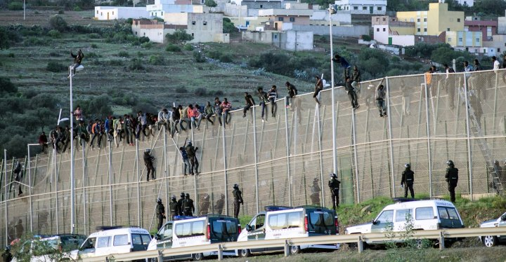
Photo: A fence which separates Moroccan territory from Spanish territory.
INTERVIEW WITH KURDISH REFUGEES from Syria

- Hello, guys. How old are you two?
Said: I´m 19.
Zana: i´m 20.

- What is your nationality?
Said and Zana: We are Kurds.

- Do you experience any discrimination because of that?
Said: Yes, there are 80 mio of us in the whole world, but we don’t have our country. We are unwanted in Turkey, Siria, Iran and Irak.

- So did you come to Germany alone or with your families?
Said: I came alone. My family still lives in Siria, my sister lives in Irak, she is married and she is on her way to Germany.
Zana: I came alone, my brother and sister live in Poland, my parents and other brothers and sisters live in Siria, but my wife is joining me in Germany soon.

- Why are Sirians leaving their country?
Zana: Because life in Siria is expensive and you spend more money that you get. All though there is enough food, safety is a big problem there. The issue for most men is the war, the government can knock on your door any time and call you to the army. That’s why a lot of young men are leaving country.

- How did you come here?
Zana and Said: Somebody drove us for a bit and we also walked quite a big part of our journey. We passed Turkey, Bulgary, Serbia, Hungary and Austria.

- Where do you live?
Said: I live in a container in Bad Wurzach.
Zana: I live in one-room apartment in Isny. Sometimes the refugees live with another family, or in special homes for refugees.

- What do you think about future of Siria?
Zana and Said: It will take a long time for Siria to become a better place. But all of this is also good for the Kurdish people.

INTERVJU S KURDSKIMA BEGUNCEMA iz SIRIJE

- Pozdravljena, koliko sta stara?
Said: Jaz imam 19 let.
Zana: Jaz pa 20 let.

- Kakšne narodnosti sta?
Said in Zana: Sva Kurda.

- Sta zaradi narodnosti ze izkusila kakšno obliko diskriminacije?
Said: Ja, na tem svetu nas je kar 80 mio, a še vedno nimamo svoje države. Nezaželjeni smo predvsem v Turčiji, Siriji, Iranu in Iraku.

- Sta v Nemčijo prišla Zana ali z družinami?
Said: Prišel sem sam. Moja družina še vedno živi v Siriji. Sestra živi v Iraku, je poročena in že na poti v Nemčijo.
Zana: Tudi jaz sem prišel sam. Moja brat in sestra živita na Poljskem, starši in ostali pa v Siriji. Moja žena se mi bo kmalu pridružila v Nemčiji.

- Zakaj Sirijci zapuščajo svojo državo?
Zana: Življenje v Siriji je zelo drago. Porabiš več, kakor zaslužiš. Čeprav je hrane dovolj, je velik problem varnost. Največji vzrok izseljevanja moškega dela prebivalstva je vojna. Vlada lahko kadarkoli potrka na tvoja vrata in te pokliče v vojsko.

- Kako sta prišla sem?
Zana in Said: Prvi del poti naju je nekdo peljal, večji kos pa sva prehodila. Prečkala sva Turčijo, Bolgarijo, Srbijo, Madžarsko in Avstrijo.

- Kje živita?
Said: Živim v „kontejnerju“ v Bad Wurzachu.
Zana: Jaz pa v enosobnem stanovanju v Isnyju. Včasih begunci živijo tudi z drugimi družinami ali pa v posebnih domovih, ki so namenjeni prav njim.

- Kakšna se vam zdi prihodnost Sirije?
Zana in Said: Trajalo bo veliko časa, da se stanje poboljša; verjameva pa, da je vse to dobro za Kurde.

